Oxalis Community Annual Plenary Meeting
(Digital meeting)
March 25th 2021, Online

Call for candidacies
Oxalis Community Management Team

Last updated March 5th 2021

Oxalis Community
c/o Norstella, Bondistranda 43, box 70
1371 Asker, Norway
Table of Contents
1 Introduction 2

1.1 Background for this call 2

1.2 Roles, Responsibility and terms of office 2

1.3 Size and structure of the Oxalis Community Management 2
2 Call for candidates 3

2.1 Submission of candidacies 3

2.2 Withdrawal of candidacies 3

2.3 Election of candidates 4

Introduction
As stated in the provision the Oxalis community will be managed and organised by elected representative of the community gold member organisations.
This document covers the call for candidacies to the Oxalis governance positions together with an overview of the requirement to the candidates and the deadlines for submitting candidacies. For information on the election process, please refer to documentation on the oxalis.network site.
  - Background for this call
This first Annual Plenary Meeting marks the approval and implementation of a permanent governance structure in the Oxalis Community.

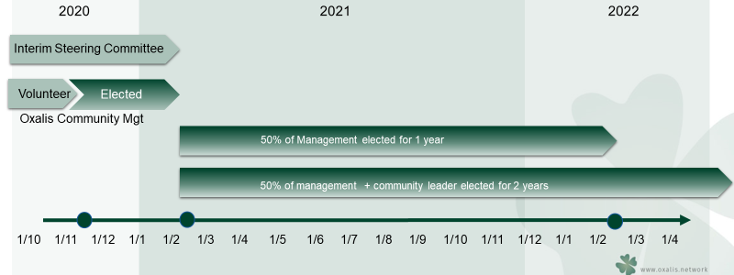

  - Roles, Responsibility and terms of office
As stated in the governance model, the Oxalis Community Management primary tasks are:
- Strategic change management; defining the strategic priority of changes
- Oxalis Community governance
- Appointing a Chair
- Appointing an observer to the e-Delivery Community in OpenPeppol.

As stated in the governance model, 50% of the members of the Management Team will be elected for a term of 1 year, and 50% will be elected for a term of 2 years. A practical implementation is that 2 or 3 candidates will be elected for a 1 year term, and 2 or 3 candidates will be elected for a 2 year term.
A “year” starts immediately after the Annual Plenary Meeting has ended and runs until the next Annual Plenary Meeting has ended.

  - Size and structure of the Oxalis Community Management
The Oxalis Community have established Management Team, elected for the duration of the interim period leading up to this first Annual Plenary Meeting. This management team have consisted of 5 members, these positions are up for election in the Annual Plenary Meeting.

Call for candidates
The call for candidates is open for all members with voting rights to consider, should anyone have the motivation and possibility to raise their candidacy.
Only persons representing member organisations with voting rights can be submitted as candidates.
  - Submission of candidacies
Submission of candidacies are requested by EOB March 18th, 2021
Submission of candidacies are done by sending a mail:
To: oxalis@norstella.no,
Subject: Submission of candidate to the Oxalis Management Team
Content of the mail:
- full name of the candidate
- member organisation
- short motivation paragraph for the candidacy.

An overview of candidates will be distributed directly to organisations with voting rights in advance of the Annual Plenary Meeting, together with details about the voting procedures.
The candidates will be presented during the Annual Plenary Meeting, where an anonymous ballot will be conducted during the meeting.

  - Election of candidates
At the meeting the organisations with voting rights will be invited to:
- Formally approve the terms
- Evaluate the registered candidates
- Elect the management positions by anonymous electronic ballot.

Election procedures will be distributed together with the presentation of candidates, no later than March 18th 2021.

Oxalis gold members
Please ensure that the submitted candidate are interested in the candidacy before submission

